UMBC Startup Companies

JAK cBroker is a software solution for (semi) automatic discovery, negotiation, and procurement of Cloud based applications or services. For more information, please visit; http://www.jaktec.com/our-solutions
To replace traditional antibiotics, mycoInnovation is developing feed additives for the agricultural industry. These will promote animal growth, improve animal health, and increase food safety. MycoInnovation is currently conducting research with a team of collaborators to develop a number of products. For more information, please visit; http://www.mycoinnovation.com

Lyse-it can rapidly lyse any bug, bacteria or algae in under 30 seconds with an astounding 100% lysing efficiency. For more information, please visit;
http://www.lyse-it.com/index.html

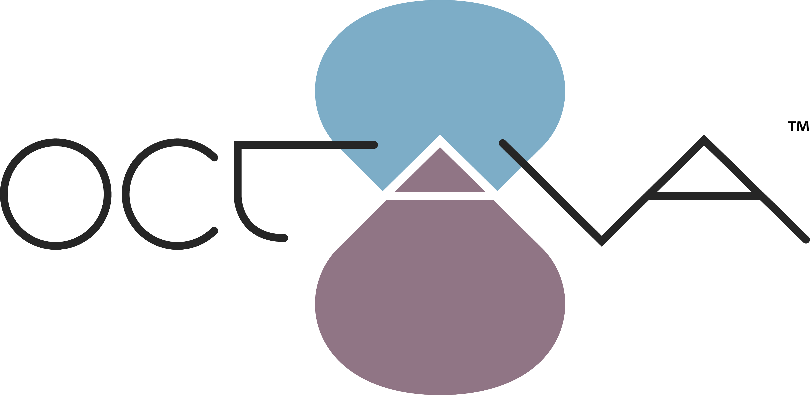 The Octava system provides performing arts venues with the ability to enrich a performance with supplemental information delivered in real time to a smartphone or tablet. For more information, please visit; http://octavaonline.com

Orablas LLC. Orablas, LLC., is commercializing ground-breaking wearable sensors and associated analytics for sleep monitoring. The system goes beyond existing activity monitors to provide accurate measures of sleep texture and diagnosis of sleep diseases. For more information, please visit; http://www.orablas.com/

Tarsier Optics LLC. Tarsier Optics will provide ‘panoramic’ photographs with micron level resolution at distances of ten miles using cell phone like lenses creating high value in the government surveillance, commercial surveying and consumer specialty camera markets. For more information, please visit; http://www.tarsieroptics.com/about.html

